**Lambda function to create a VPC**

***AWS Lambda*** is **a serverless compute service that runs your code in response to events and automatically manages the underlying compute resources for you**. These events may include changes in state or an update, such as a user placing an item in a shopping cart on an ecommerce website.

**What is meant by AWS VPC?**

A virtual private cloud (VPC) is **a virtual network dedicated to your AWS account**. It is logically isolated from other virtual networks in the AWS Cloud. You can specify an IP address range for the VPC, add subnets, add gateways, and associate security groups. A subnet is a range of IP addresses in your VPC.

Steps to create an AWS VPC using Lambda :

## **Step 1** >> Go to AWS Console → Lambda → Create Function.

## Add name to your function

## Choose the language to use to write your function

## In the Permissions, create an IAM role with Administrator Access policy

## Select the execution role that you have created

## **Step 2** >> After creating the Lambda function write the following code in the code section to create a VPC :

import boto3

ec2 = boto3.resource('ec2')

def lambda_handler(event, context):

vpc = ec2.create_vpc(CidrBlock='192.168.0.0/16') #creating VPC

vpc.create_tags(Tags=[{"Key": "Name", "Value": "my_vpc"}]) #Assigning name to VPC

print(vpc.id) #printing id of the VPC

ig = ec2.create_internet_gateway() #creating internet gateway

vpc.attach_internet_gateway(InternetGatewayId=ig.id) #attaching internet gateway to my vpc

print(ig.id)

route_table = vpc.create_route_table() #creating route table and a public route to Internet Gateway

route = route_table.create_route(

DestinationCidrBlock='0.0.0.0/0',

GatewayId=ig.id

)

# Create a Subnet

subnet = ec2.create_subnet(CidrBlock='192.168.1.0/24', VpcId=vpc.id)

print(subnet.id)

# associate the route table with the subnet

route_table.associate_with_subnet(SubnetId=subnet.id)

Step 3 >> **Run a test**

* Go to Test and create a test event
* 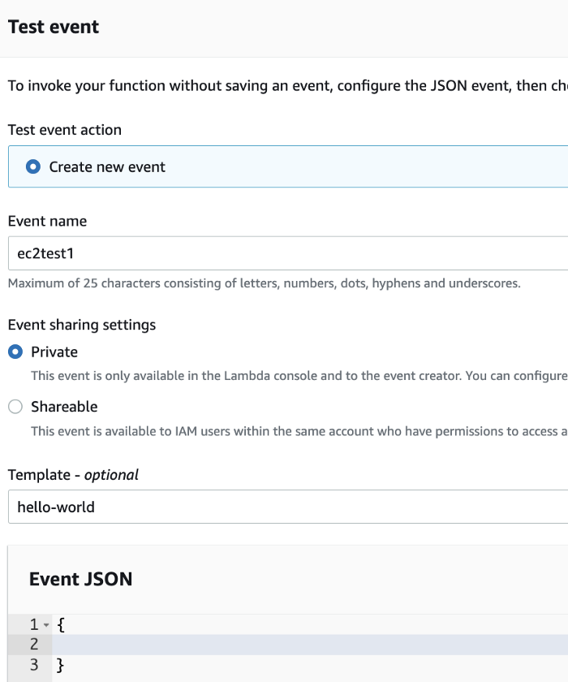
* Test it. You should see a successful execution.

